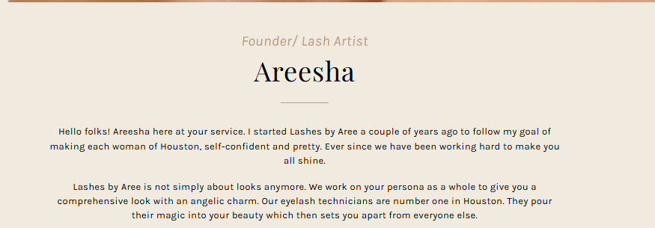Founder/ Lash Artist

Areesha
Hello folks! Areesha here at your service. I started Lashes by Aree a couple of years ago to follow my goal of making each woman of Houston self-confident and pretty. Located at the heart of Houston, Lashes by Aree provides the utmost level of quality with its Eyelash extensions.

If you are looking for the best lash extensions in Houston, look no further. Lashes by Aree is here to make your lashes look longer, darker, and prettier with their high-quality extensions. Our skilled Eyelash technicians are the best across Houston and are ever-ready to give you the lashes that you deserve.

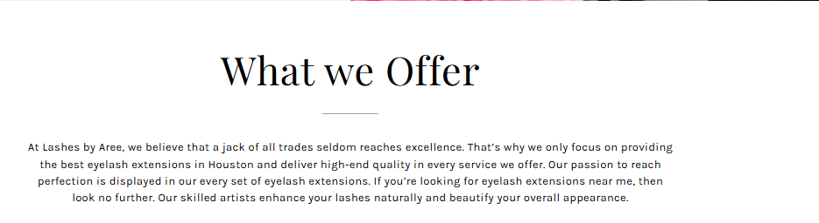Explore Our Eyelash Extension Services in Houston
At Lashes by Aree, our lash professionals only focus on providing the best eyelash extensions in Houston and delivering high-end quality in every service we offer. Our passion to reach perfection is displayed in every set of eyelash extensions.
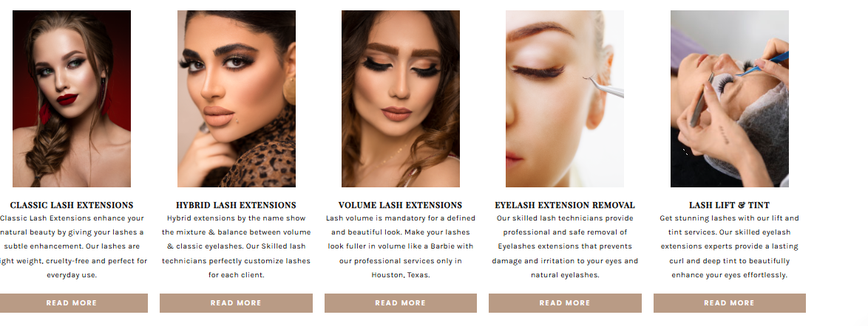
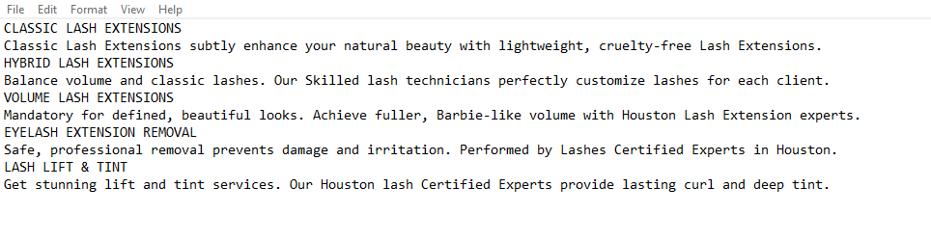
CLASSIC LASH EXTENSIONS | HYBRID LASH EXTENSIONS | VOLUME LASH EXTENSIONS | EYELASH EXTENSION REMOVAL | LASH LIFT & TINT
Classic Lash Extensions subtly enhance your natural beauty with lightweight, cruelty-free Lash Extensions. | Hybrid lash extensions bring balance between volume and classic lashes, which we customize for each client. | Mandatory for defined, beautiful looks. Achieve fuller, Barbie-like volume with Houston Lash Extension experts. | Safe, professional removal prevents damage and irritation. Performed by Lashes Certified Experts in Houston. | Get stunning lift and tint services. Our Houston lash Certified Experts provide lasting curl and deep tint.

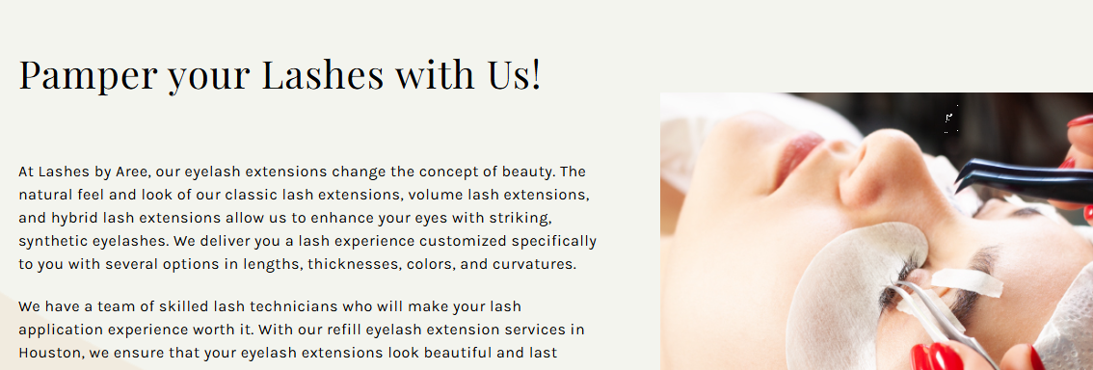Houston’s Premium Eyelash Extensions

At Lashes by Aree, our eyelash extensions change the concept of beauty. The natural feel and look of our classic lash extensions, volume lash extensions, and hybrid lash extensions allow us to enhance your eyes with striking, synthetic eyelashes. We deliver you a customized lash experience with several options in lengths, thicknesses, colors, and curvatures.

We have a team of skilled lash technicians who will make your lash application experience worth it. We offer extensive consultation for you to start your lash journey easily. Our services highlight significant differences in eyelash extensions before and after application. Get your favorite eyelash extension services now in Houston by contacting us.

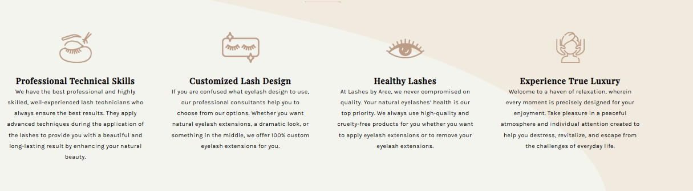Upgrade Your Lash Game:

Professional Technical Skills | Customized Lash Design | Healthy Lashes | Experience True Luxury
We have the best professional and highly skilled, well-experienced lash technicians who always apply advanced techniques to provide you with long-lasting results. | If you're unsure about which eyelash design to choose, our professional consultants can help you select from our options. We offer 100% custom eyelash extensions for you. | At Lashes by Aree, we never compromise on quality. The health of your natural eyelashes is our top priority. We always use high-quality and cruelty-free products for you. | Welcome to a haven of relaxation, wherein every moment is precisely designed for your enjoyment. Enjoy a peaceful atmosphere intended to help you unwind and destress.

FAQ’s

Will eyelash extensions hurt my natural lashes? (H3)
No. The natural lashes do not fall out due to the procedure, but after their natural lifespan is over. Our skilled experts from all over Houston handle eyelash extensions with extra care so that nothing of this sort happens.

Do I need to prep before my eyelash extension appointment? (H3)
Try not to use any eye makeup for at least a day or two before until your appointment. Only then will you get the best results from eyelash extensions.

How long does it take to apply lash extensions? (H3)
Most lash studios in Houston take around 1.5 hours to apply a full set of lashes. Our eyelash extensions near me salon makes the process comfortable and relaxing, so it does not feel like a lot of time when you’re in the process.

How long will my new lashes last? (H3)
A new set of lashes can last from 2 to 4 weeks, depending on your skincare routine and your own natural lash life cycle. Even the best lashes in Houston will last almost the same time, so it is recommended that you get your refills every 3 weeks.

How do I take care of my new lash extensions? (H3)
Since you’re getting the Best Eyelash Extensions In Houston Tx, you don’t need to worry about this a lot. Try to keep your lashed dry for at least 24hrs after application. Avoid exposure to heat, steam, sauna and friction and you must be good to go.

How often should I be coming to the Lash studio for refills? (H3)
It is recommended that you get refills every 2 to 4 weeks. If you wait too long, your eyelash extensions may fall out, and you’ll need a full set. Try getting them refilled when they are 50%-60% gone.

Can I apply makeup or mascara to my lash extensions? (H3)
Yes, you can. The catch here is that you must only apply water-based mascara. The experts of our best Eyelash Extensions In Houston Tx salon suggest you should avoid an oil-based or waterproof mascara.

